How to take a Screen Short:
Confirming you have successfully completed your SCaN Training
Depending on how you have accessed the SCaN training will determine how to take a screen shot and follow the submission approach as detailed on the website page.
Below are the instructions for the following ways to capture a screenshot of the completed training:
- Taking a photo and sending it via email on an iPhone
- Taking a photo and sending it via email on an Android
- Screenshot from an iPhone 9
- Screenshot from iPhone X onwards or iPad
- Screenshot from an Android phone or tablet
- Take a Print Screen shot from a Mac

Taking a photo and sending it via email on an iPhone:
Take a photo of the final screen of SCaN training and submit as detailed on the website page.

Open the mail app on your iPhone and select who you would like to send the picture to. Write their address in the To section.
Subject Evidence of Completed SCaN Training.

Go to the < above the keyboard. This will open out the photo/camera icons.
Choose the photo option and select the correct image by touching the square it is in. A blue tick should appear to show it is selected. To deselect just click the image and the blue tick will disappear.

Once you are happy with the selection, please write in the body of the email, your name and date of completion and press send.
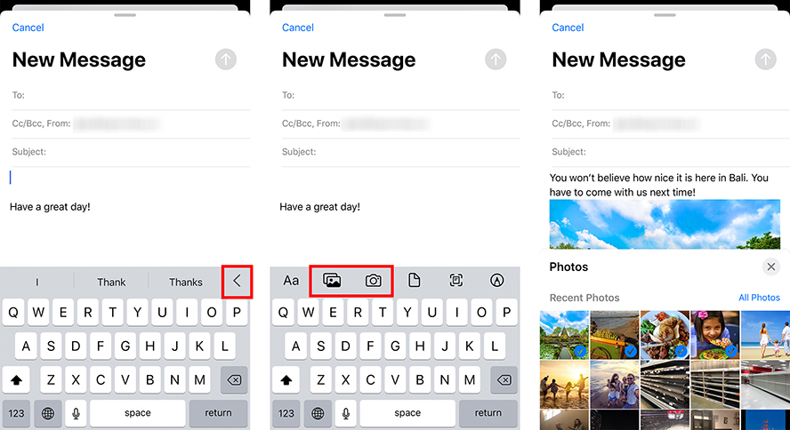

Taking a photo and sending it via email on an Android:
Open the photo app on your phone. In the photo gallery, long press the photo you would like to share until it shows as selected. A dot (or a check mark) will appear in the corner.

Tap the Share icon and choose your desired email. The share icon ( ) is two small arrows with one circle between them.

After tapping the share icon, you are given a number of options, depending on the accounts associated with the phone. Android phones most commonly have a "Gmail" account. Once email is selected this will carry the chosen photos into a new window, where they will be attached to an email.
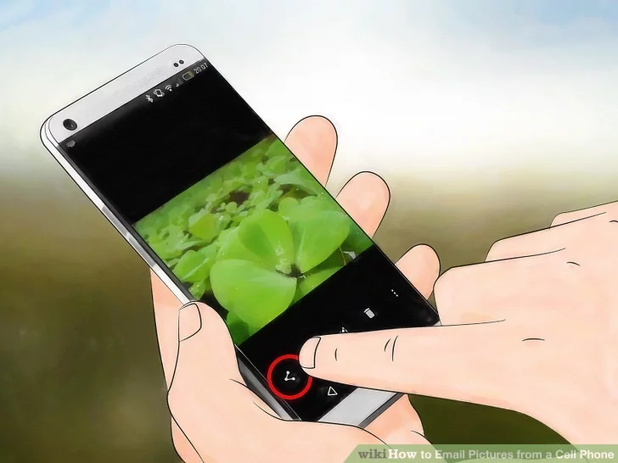

To: add the email address
Subject: Evidence of Completed SCaN Training
In the body of the email, your name and date of completion and press send.

Screenshot from an iPhone 9
Press the Top button and the Home button at the same time. Quickly release both buttons. After you take a screenshot, a thumbnail appears temporarily in the bottom left-hand corner of your screen. Tap the thumbnail to open it or swipe left to dismiss it.
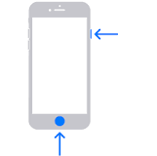

Then follow the procedure above to send via an email.

Screenshot from iPhone X onwards or iPad
Press the Side button and the Volume up button at the same time.
Quickly release both buttons.
After you take a screenshot, a thumbnail appears temporarily in the bottom left-hand corner of your screen. Tap the thumbnail to open it or swipe left to dismiss it.

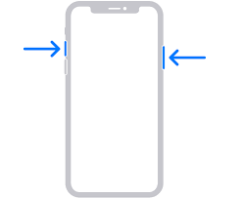

Then follow the instructions above to send the screenshot by email.

Screenshot from an Android phone or tablet
When you want to take a screenshot, just hold the Volume down key and the Power key (Side key) simultaneously.
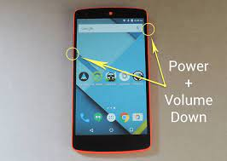

Then follow the instructions above to send the screenshot via email.

Take a Print Screen shot from a windows laptop/desktop.
When you have completed the SCaN training and see the final screen saying you have completed the training. You need to take an image of this using the print screen button.
Look at the keyboard and locate the two buttons pictured below. Hold the Windows key and whilst still holding this down press the Print Screen key. This will hold a “shot” of what you are seeing on the screen in a cache.

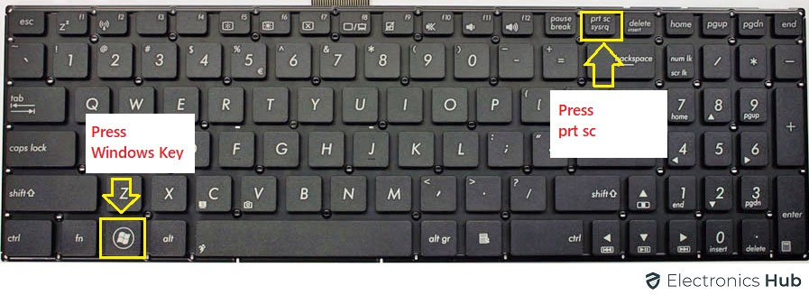
To send via email, open your email account and a new email. Place your cursor in the body of the message and right click your mouse or mousepad.

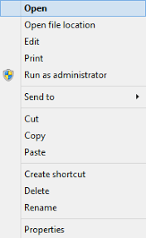

Scroll down to paste and the print screen shot of your certificate will show up in the email message.
Then in
To: add the email address
Subject Evidence of Completed SCaN Training.

Take a Print Screen shot from a Mac.
When you have completed the SCaN training and see the final screen saying you have completed the training. You need to take an image of this using the print screen button.
Press Shift-Command-4, then move the crosshair pointer to where you want to start the screenshot. Press the mouse or trackpad button, drag over the area you want to capture, then release the mouse or trackpad button.
When you take a screenshot on your Mac, it is automatically saved to your Desktop. You can find them either by navigating to your Desktop screen, or using Finder to open the Desktop folder and see your saved images there
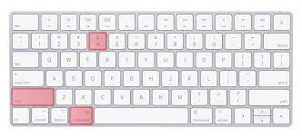
You can then send via email by locating the saved image in your Desktop folder.
Open the mail app on your Mac and select who you would like to send the picture to.
Write their address or volunteering@stpaulscathedral.org.uk in the
To add the email address
Subject Evidence of Completed SCaN Training.

