**Instructions:   
Downloading your certificate from the Church of England safeguarding training portal**

**How to find your certificate**

*Please note that, once you have completed a course's Final Assessment, there will still be one or two pages to work through, and the course will not be recorded as having been completed until the "Finish" button has been clicked on the final page.*

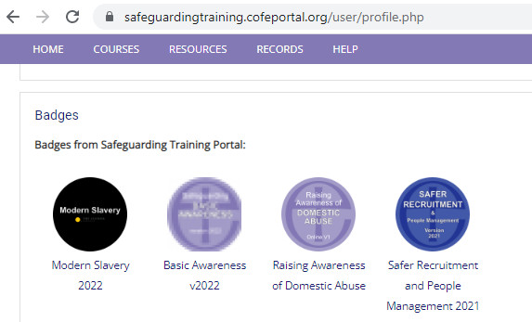Once you have successfully completed a course, you will be issued a badge that displays on your profile (click your name at the top right of the screen and select [**View Profile**](https://safeguardingtraining.cofeportal.org/user/profile.php)).

**Please note**: the badge may take up to ten minutes to appear.  
  
If you click on the badge's icon, its information page will load - this contains a link which will allow you to download your certificate.  
  
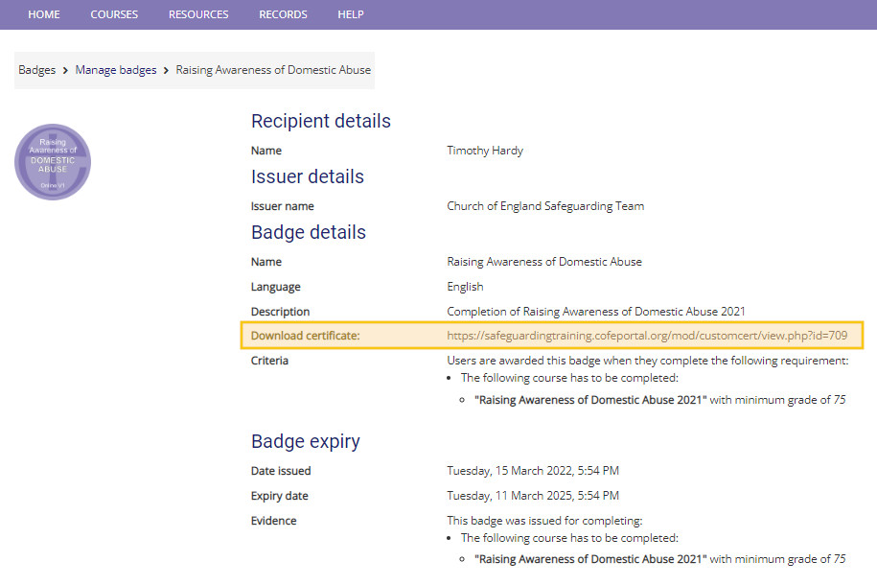

Once you have downloaded the certificate, it will also appear on your "My Certificates" page, which is available either by following the link on your "My Records" page or by following the link below:

[**https://safeguardingtraining.cofeportal.org/mod/customcert/my_certificates.php**](https://safeguardingtraining.cofeportal.org/mod/customcert/my_certificates.php)